Phil Barnes – A Craftsman’s Journey

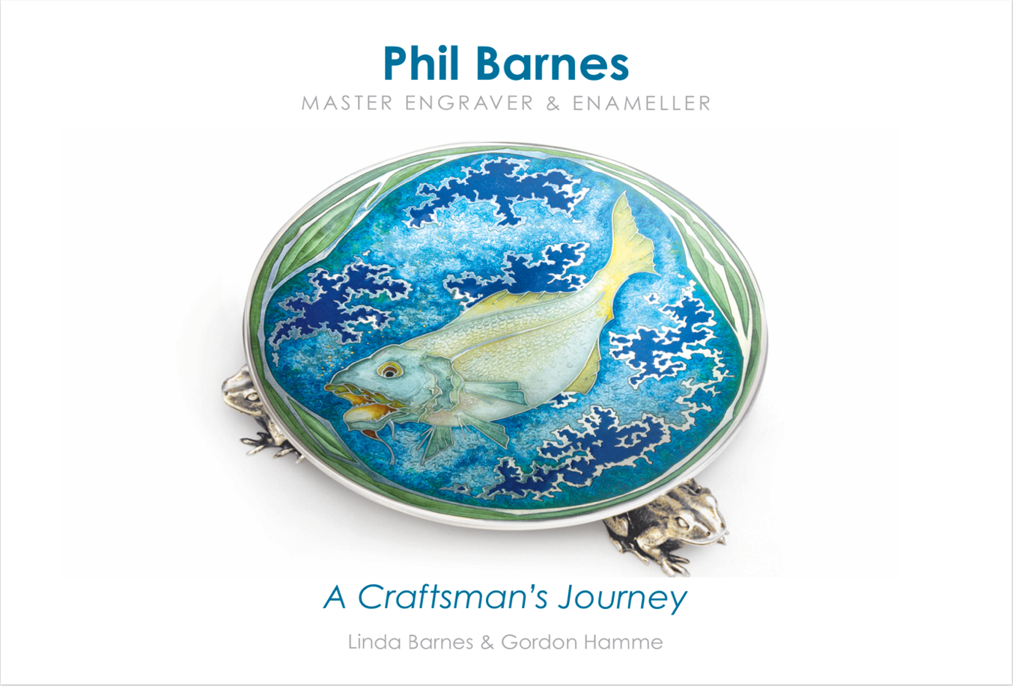

Linda Barnes & Gordon Hamme have collaborated on writing the life story of the world class enameller Phil Barnes.
Barnes had always intended to publish an account of life in the workshop not only as a personal history but as an important social history of the jewellery trade. The text includes his written record and information transcribed from a series of interviews he recorded with Gordon for his PhD.
Phil Barnes began his enamelling career in 1967, at the age of fifteen, following in his father’s footsteps. He completed his apprenticeship with his father’s company in 1971, winning the coveted Jaques Cartier “Craftsman of the Year” Memorial Award in the same year. He went on to become a working partner in the business and later set up his own workshop in Clapham, London following his father’s retirement in 1983.
The book is a record of Phil Barnes’ working life and career, a master in the art of engraving and enamelling, which is richly illustrated with many of his finest pieces. It gives a unique insight into his own life as an apprentice and master and the jewellery trade from the 1920s when his father first began his own apprenticeship.
This book appeals not only to craftsmen, but anyone interested in the jewellery trade in pre- and post-war London. As a social history it documents a world all but forgotten and as a personal journey it provides a fascinating slice of life, describing the everyday aspects of an elite world.
Flip book link: https://simplebooklet.com/wNM0iEyh6zJFGUm2YajbKI
Click on this link to see a sample of the Phil Barnes book.

To purchase the book visit https://www.festivalofsilver.co.uk/product-page/phil-barnes-a-craftsman-s-journey

